3.2 Data Analysis on Cloud

* Move the Data Set to Azure Synapse Storage Gen2

To move our Loan Dataset to Azure Storage, we used synapsefordbi which was given already.

Next step is, we created folder named Capstone5 to upload datafiles from local system to azure data storage.

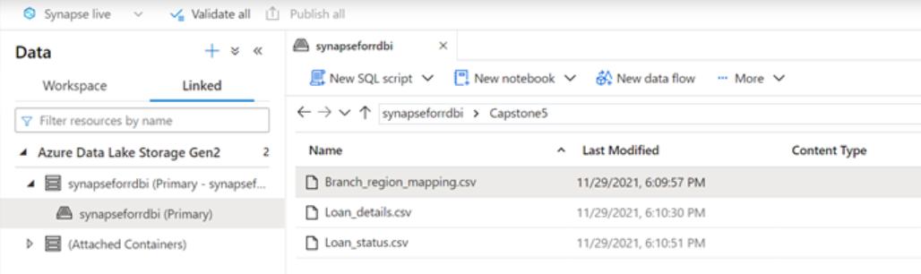

* Create a serverless SQL pool to query the data from Storage gen 2

After creating serverless SQL pool, we create three external data sources.

1. CREATE EXTERNAL DATA SOURCE BranchRegion

WITH ( LOCATION = 'https://synapase2811.blob.core.windows.net/Capstone5')

1. CREATE EXTERNAL DATA SOURCE LoanDetails

WITH ( LOCATION = 'https://synapase2811.blob.core.windows.net/Capstone5')

1. CREATE EXTERNAL DATA SOURCE LoanStatus

WITH ( LOCATION = 'https://synapase2811.blob.core.windows.net/Capstone5')

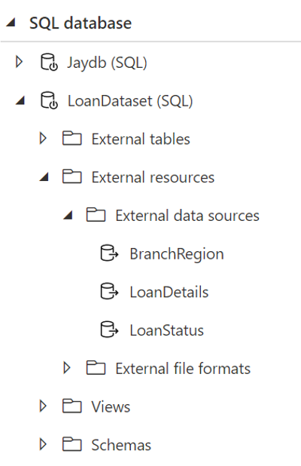

Next step is after creating external data sources, we created three views for each data source.

1. CREATE VIEW BranchRegion_view AS

SELECT

C1 as branch_id,

C2 as region

FROM OPENROWSET

(BULK 'https://synapseforrdbi.dfs.core.windows.net/synapseforrdbi/Capstone5/Branch_region_mapping.csv',

format = 'csv', parser_version = '2.0', firstrow = 2 ) as rows

1. CREATE VIEW LoanDetails_view AS

SELECT

C1 as Loan_id,

C2 as disbursed_amount,

C3 as asset_cost,

C4 as ltv,  C5 as branch_id,

C6 as [Date.of.Birth],

C7 as [Employment.Type],

C8 as DisbursalDate,

C9 as MobileNo_Avl_Flag,

C10 as Aadhar_flag,

C11 as PAN_flag,

C12 as VoterID_flag,

C13 as Driving_flag,

C14 as Passport_flag,

C15 as [PERFORM_CNS.SCORE],

C16 as [DELINQUENT.ACCTS.IN.LAST.SIX.MONTHS],

C17 as [CREDIT.HISTORY.LENGTH],

C18 as [NO.OF_INQUIRIES]

FROM OPENROWSET

(BULK 'https://synapseforrdbi.dfs.core.windows.net/synapseforrdbi/Capstone5/Loan_details.csv',

format = 'csv', parser_version = '2.0', firstrow = 2 ) as rows

1. CREATE VIEW LoanStatus_view AS

SELECT

C1 as Loan_default,

C2 as loan_id

FROM OPENROWSET

(BULK 'https://synapseforrdbi.dfs.core.windows.net/synapseforrdbi/Capstone5/Loan_status.csv',

format = 'csv', parser_version = '2.0', firstrow = 2 ) as rows

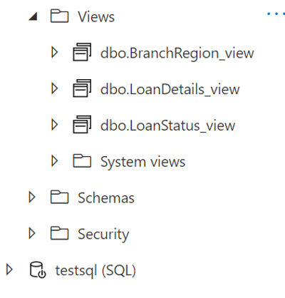

After creating views, we queried our dataset to view data.

* Create a Linked service to PowerBI

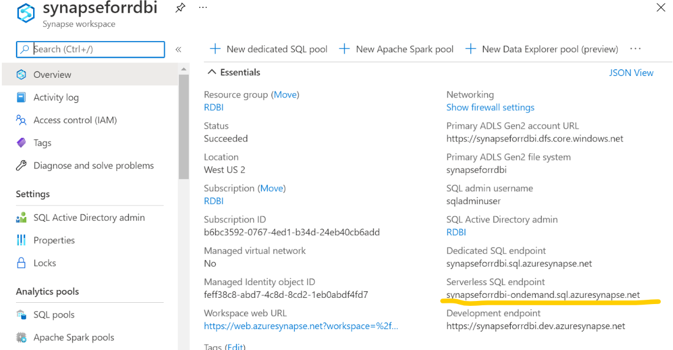

From this, we took the serverless sql end point and used that to connect azure synapse storage with desktop power bi. 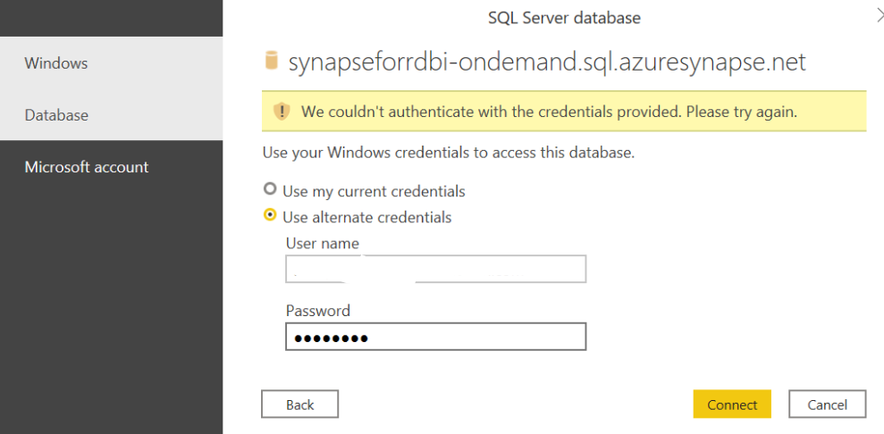

To link azure with PowerBI, in the desktop Power Bi “Get Data” from azure.

After loading dataset in Local system Power Bi from Azure Storage, will be able to see data fields.

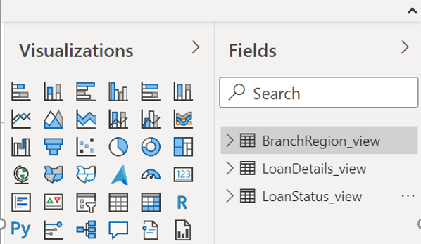

Below queries shows, how dataset is connected to azure synapse.

* Perform various analytics on PowerBI

After loading dataset successfully, various analytics performed as given below.

* Ensure you have sufficient privileges on Synapse to access the serverless sql pool.
* Perform the tasks mentioned in Task 2.3
  + What were the total enquiries done?

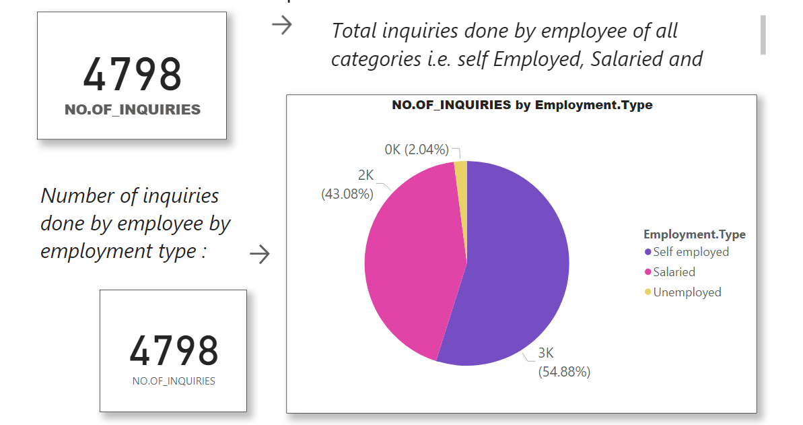

* + What was the maximum asset cost?

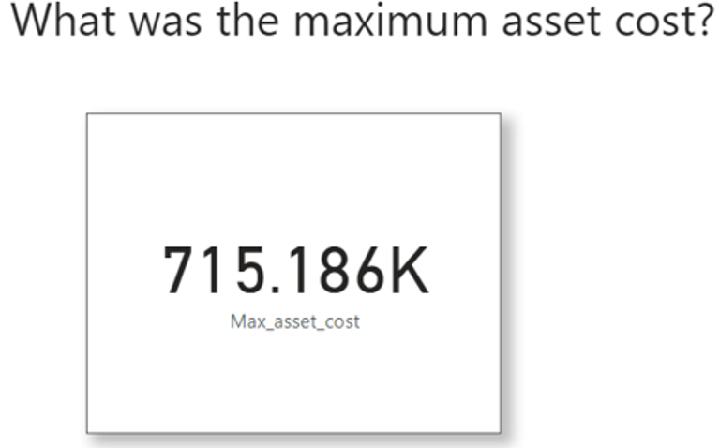

* + What is the average asset cost for each employment type?

* + What is the average loan default for each driving flag?

* + Display to Key Influencer Visual for the appropriate columns and indicate your inferences.

* + Display loan default by employment type and indicate which employment type has the highest loan default.

* + Display a decomposition tree for the data.

